Facial Recognition Systems with the Firefly Algorithm
Deepanjal Sood, Ankit Anupam Rout, Dr. Law Kumar Singh
Amity School of Engineering and Technology, Amity University Punjab, Mohali
Emails: deepanjal42@gmail.com, ankitanupam3@gmail.com, lawkumarcs1@gmail.com

Abstract
Facial recognition technology has developed very quickly and is now a crucial element in contemporary security systems, mobile phone biometric authentication, and mass surveillance networks. Despite its extensive use, facial recognition system performance can be greatly affected by changes in lighting conditions, occlusions, poses, and expressions. These tend to hamper the system's capability to effectively extract and analyse useful facial features, resulting in reduced reliability in real-world usage. One of the fundamental factors determining recognition accuracy is the effectiveness of the feature selection and classification process. In this work, we introduce a new hybrid approach that combines the Firefly Algorithm, a nature-inspired metaheuristic optimization algorithm, with Linear Discriminant Analysis (LDA) for dimensionality reduction and Random Forest for classification. The Firefly Algorithm is used to determine the most discriminative and separable features from the dataset, thus enhancing classification accuracy while reducing redundant computations. Our experimental framework employs the Labelled Faces in the Wild (LFW) database, which offers a realistic and varied testbed for performance assessment. The suggested approach shows evident superiority over traditional systems, with higher detection rates, reduced recognition times, and greater robustness in the presence of noise and real-world artefacts. Comparative outcomes indicate that the model produces a recognition rate of 93.2%, which is superior to typical LDA-based and randomly optimized systems. This study points to the strength of using evolutionary optimization in conjunction with statistical learning techniques to develop a facial recognition pipeline that is not only accurate but also computationally fast and robust against real-world conditions.

Keywords - Face Recognition, Firefly Algorithm, Feature Selection, Linear Discriminant Analysis (LDA), Random Forest, Optimization Algorithms, Biometric Authentication, Machine Learning, Pattern Recognition

1. Introduction

Facial recognition technology has become a cornerstone of modern security and authentication systems, reshaping how we interact with devices and secure environments. From unlocking smartphones with a glance to streamlining airport security checks, verifying financial transactions, and enabling smart access control in buildings, this technology offers a fast, secure, and user-friendly alternative to traditional methods like passwords, PINs, or keycards [1][2]. By leveraging the unique biometric traits of an individual’s face, facial recognition provides a non-intrusive way to confirm identity, reducing the risks associated with lost, stolen, or forgotten credentials. The widespread adoption of this technology has been driven by significant advancements in deep learning, particularly convolutional neural networks (CNNs), which excel at extracting robust and distinctive facial features even under varying conditions such as different lighting or angles [3]. Despite these strides, real-world deployment remains challenging due to factors like illumination changes, pose variations, occlusions (e.g., scarves or glasses), and diverse facial expressions, all of which introduce significant intra-class variability that can degrade performance [4][5].
Traditional facial recognition methods, such as Principal Component Analysis (PCA), Linear Discriminant Analysis (LDA), and Support Vector Machines (SVM), have been widely used but often fall short when handling complex, high-dimensional data or non-linear decision boundaries [6]. These approaches struggle to balance computational efficiency with accuracy, particularly in unconstrained environments where faces may appear under diverse conditions. To address these limitations, researchers have increasingly explored hybrid models that combine statistical learning techniques with nature-inspired metaheuristic optimization algorithms. Methods like Genetic Algorithms (GA), Particle Swarm Optimization (PSO), and the Firefly Algorithm (FA) draw inspiration from natural processes to intelligently navigate high-dimensional search spaces, optimizing feature selection and improving classification accuracy [7][8]. Among these, the Firefly Algorithm, developed by Xin-She Yang, is particularly notable for its simplicity and effectiveness. It models the flashing behaviour of fireflies, where the brightness of each flash represents a solution’s fitness, guiding the algorithm toward optimal solutions through attraction and movement [9]. This approach is well-suited for tasks like feature selection, where identifying the most discriminative features is critical for robust recognition.
The growing demand for facial recognition in applications like surveillance, biometric authentication, and human-computer interaction has also highlighted the need for systems that are not only accurate but also computationally efficient and adaptable to real-time constraints. Many existing models, while accurate in controlled settings, require significant computational resources or fail to generalize well in dynamic environments [10]. Furthermore, the reliance on manual feature engineering or suboptimal feature selection methods can lead to redundancy, increasing processing time and reducing model performance on unseen data. Hybrid frameworks that integrate optimization-driven feature selection, dimensionality reduction, and robust classification offer a promising solution to these challenges, enabling systems that are both practical and high-performing.

Figure 1 (Facial Recognition System)
This study proposes a novel hybrid facial recognition framework that synergistically combines the Firefly Algorithm for feature selection, Linear Discriminant Analysis (LDA) for dimensionality reduction, and a Random Forest (RF) classifier for robust decision-making. The framework is designed to address the shortcomings of traditional methods through a three-stage pipeline.
The contributions of this work are fourfold:
- Firefly Algorithm for Smart Feature Selection: The Firefly Algorithm intelligently filters raw facial features to identify the most discriminative subset, reducing noise and enhancing the model’s ability to generalize to new faces.
- LDA for Streamlined Data: Selected features are projected into a lower-dimensional space, preserving class-discriminative information while minimizing computational overhead.
- Random Forest for Reliable Classification: An ensemble of decision trees classifies the refined features, ensuring high accuracy and resilience to environmental variations like lighting or pose changes.
We tested this model on the Labelled Faces in the Wild (LFW) dataset, which includes 13,233 images of 5,749 people and is known for its real-world challenges like varying poses and lighting [11]. Our hybrid approach outperforms traditional methods like LDA alone or random feature selection, delivering better accuracy, faster processing, and stronger performance in tough conditions.
The key contributions of our model are fourfold:
- Hybrid Optimization-Driven Framework: Blends optimization, feature selection, and classification into one, optimized face recognition pipeline.
- Intelligent Feature Selection Using Firefly Algorithm: Employing the Firefly Algorithm to select the most important facial features automatically through simulating swarm intelligence.
- Improved Recognition Accuracy and Speed: Improves both the accuracy and processing speed of face recognition over conventional approaches.
- Robustness in Unconstrained Environments: Works consistently even in adverse conditions such as changing lighting, angles of the face, and obstructions.
- First deployment of FA-LDA-RF Trio in Facial Recognition: Forefronts the combination of Firefly Algorithm, LDA, and Random Forest for facial recognition applications.

The remainder of the paper is organized as follows. Section 2 is a comprehensive literature review of traditional, machine learning, and nature-inspired methods for facial recognition. Section 3 describes the methodology that is proposed, encompassing preprocessing, feature extraction methods, optimization via the Firefly Algorithm, and classification via the Random Forest classifier. Section 4 discusses the experimental setup, covering the datasets employed, parameter settings, and metrics of evaluation. Section 5 presents the results and compares the performance of the proposed model to the current techniques. Lastly, Section 6 concludes the paper by providing a summary of the major findings and recommendations for future work in the design of hybrid and intelligent facial recognition systems.

2. Literature Review

Facial recognition technology has come a long way in the last few decades, from initial statistical approaches to intelligent hybrid and ensemble-based systems. Early work by Zhao et al. [1] proposed a fusion of Principal Component Analysis (PCA) and Linear Discriminant Analysis (LDA) for the representation of facial images, which served as a foundation in early recognition systems through dimensionality reduction and class separability. These techniques, such as derivatives Eigenfaces and Fisherfaces, were popular in the 1990s and early 2000s but performed poorly in high-dimensional, non-linear, and unconstrained settings. In an attempt to overcome some of these shortcomings, Beham and Roomi [2]examined the use of machine learning classifiers like Support Vector Machines (SVM), PCA, and LDA in face recognition, with a detailed description of their advantages and pointed out their issues under noisy or highly variable data. In a more recent analysis, Kaur et al. [3] reviewed numerous facial recognition methods under diverse environmental and imaging conditions, proposing that hybrid models and optimization-led models may provide more stable performance in practical scenarios.
Nature-inspired optimization algorithms broadened the research scope of intelligent facial recognition systems. Mistry et al. [4]also suggested a hybrid feature selection model based on a micro-genetic algorithm integrated with Particle Swarm Optimization (GA + PSO) for enhancing facial emotion recognition. Their framework demonstrated higher accuracy by optimizing subsets of features prior to classification, indicating the potential of evolutionary algorithms in pre-processing. In the meantime, Yang [5] presented the Firefly Algorithm (FA), a metaheuristic algorithm motivated by fireflies' bioluminescent behaviour. FA exhibited robust convergence properties for multimodal optimization problems and flexibility to be used for feature selection in sophisticated pattern recognition systems. Extending this, Agarwal and Bhanot [6] implemented FA using a Radial Basis Function (RBF) Neural Network for improving classification rates for face recognition problems and illustrated that the combination of optimization and neural structures can be a path to substantial improvement in performance.
Zhang et al. [7] added theoretical basis to nature-inspired approaches by reviewing bio-inspired methods such as FA, GA, and PSO for their applicability in feature optimization within facial recognition workflows. Building on these concepts, the research by Mistry et al. [8] presented a Firefly Algorithm variant with added Gaussian, Cauchy, and Lévy mutation mechanisms. This strategy was coupled with an extended overlap Local Gabor Binary Pattern (LGBP) feature extraction and an ensemble based on a Support Vector Machine (SVM). Their system reported a high accuracy of 98.45% on the CK+ dataset and outperformed generalization across JAFFE and MMI datasets. Focusing on emotion recognition, the approach shows how state-of-the-art results can be obtained through more sophisticated feature selection and ensemble learning.
Simultaneously, ensemble-based models such as Random Forest (RF) have demonstrated high potential in face recognition for identity authentication, anti-spoofing detection, and expression classification because of their capacity to deal with high-dimensional data, avoid overfitting, and offer feature importance information. RF is particularly a potent tool when blended with other algorithms such as LDA or FA to optimize dimensionality and features. In contrast with deep neural networks, RF provides increased training speed, scalability, and transparency, which is well suited to edge computing, mobile deployment, and privacy-focused applications. With advancing research in facial recognition, the integration of statistical learning, evolutionary algorithms, and ensemble techniques—such as the presented FA + LDA + RF pipeline—is a highly versatile and computationally effective methodology that optimizes accuracy with explainability, particularly in constantly changing real-world environments.

Table 1
Table 1: Literature Review Table
Author | Technique | Key Contribution | Dataset / Benchmark | Performance / Accuracy
Zhao et al. (1998) [1] | PCA + LDA | Introduced discriminant analysis in PCA-based face recognition. | FERET / ORL | ~89.2%
Beham & Roomi (2013) [2] | PCA, LDA, SVM | Comprehensive review of statistical and kernel-based face recognition methods. | Yale / ORL | ~91.5%
Kaur et al. (2020) [3] | Review of Algorithms | Surveyed various face recognition techniques under pose, lighting, and occlusion. | — | Review-based (No performance reported)
Mistry et al. (2017) [4] | GA + PSO (Micro-GA-PSO) | Hybrid optimization for emotion recognition using heuristic search. | CK+ / JAFFE | ~93.6%
Yang (2009) [5] | Firefly Algorithm (FA) | Introduced FA for global optimization inspired by firefly behaviour. | Simulated test functions / Synthetic | —
Agarwal & Bhanot (2018) [6] | FA + RBF Neural Network | Enhanced recognition by combining FA with RBF neural networks. | ORL | ~94.8%
Zhang et al. (2010) [7] | FA, GA, PSO (Survey) | Reviewed nature-inspired algorithms for pattern recognition. | — | Survey-based (No performance reported)
Mistry et al. (2017) [8] | Overlap LGBP + FA variant + Ensemble (SVM) | Facial expression recognition using LGBP and enhanced FA. | JAFFE | 95.72%
Proposed Model | FaceNet + FA + LDA + RF | Combines FaceNet embeddings, FA-based feature selection, LDA for dimensionality reduction, and Random Forest classification. | LFW | 96.32%

3. Materials and Methods
Facial recognition systems tend to suffer in natural environments owing to variations in lighting, occlusions, and high-dimensional feature spaces, resulting in lower accuracy and efficiency. Conventional approaches are non-adaptive and tend to use manual or redundant feature selection, which increases computational time. This project is driven by the necessity to create a more intelligent and efficient framework using the Firefly Algorithm for optimal feature selection, LDA for reducing the dimension, and Random Forest for accurate classification. The aim is to improve accuracy, minimize memory requirements, and provide consistency in performance in unconstrained settings.

3.1 Dataset
The system utilizes the Labelled Faces in the Wild (LFW) dataset, a widely recognized benchmark containing more than 13,000 face images collected from the internet, with substantial variation in lighting, expressions, and poses.
Preprocessing steps include Grayscale Conversion: All images are converted to grayscale to reduce the number of channels and computational complexity without sacrificing crucial structural information.
Face Detection and Cropping: Faces are detected using algorithms such as Haar Cascades or Dlib’s Histogram of Oriented Gradients. Detected faces are cropped to remove unnecessary background elements. Resizing: Each cropped face is resized to a fixed dimension (e.g., 64×64 or 128×128 pixels) to ensure uniformity in the input data. Normalization: Pixel intensity values are scaled to a common range (e.g., [0,1]) and histogram equalization is optionally applied to counteract illumination disparities.

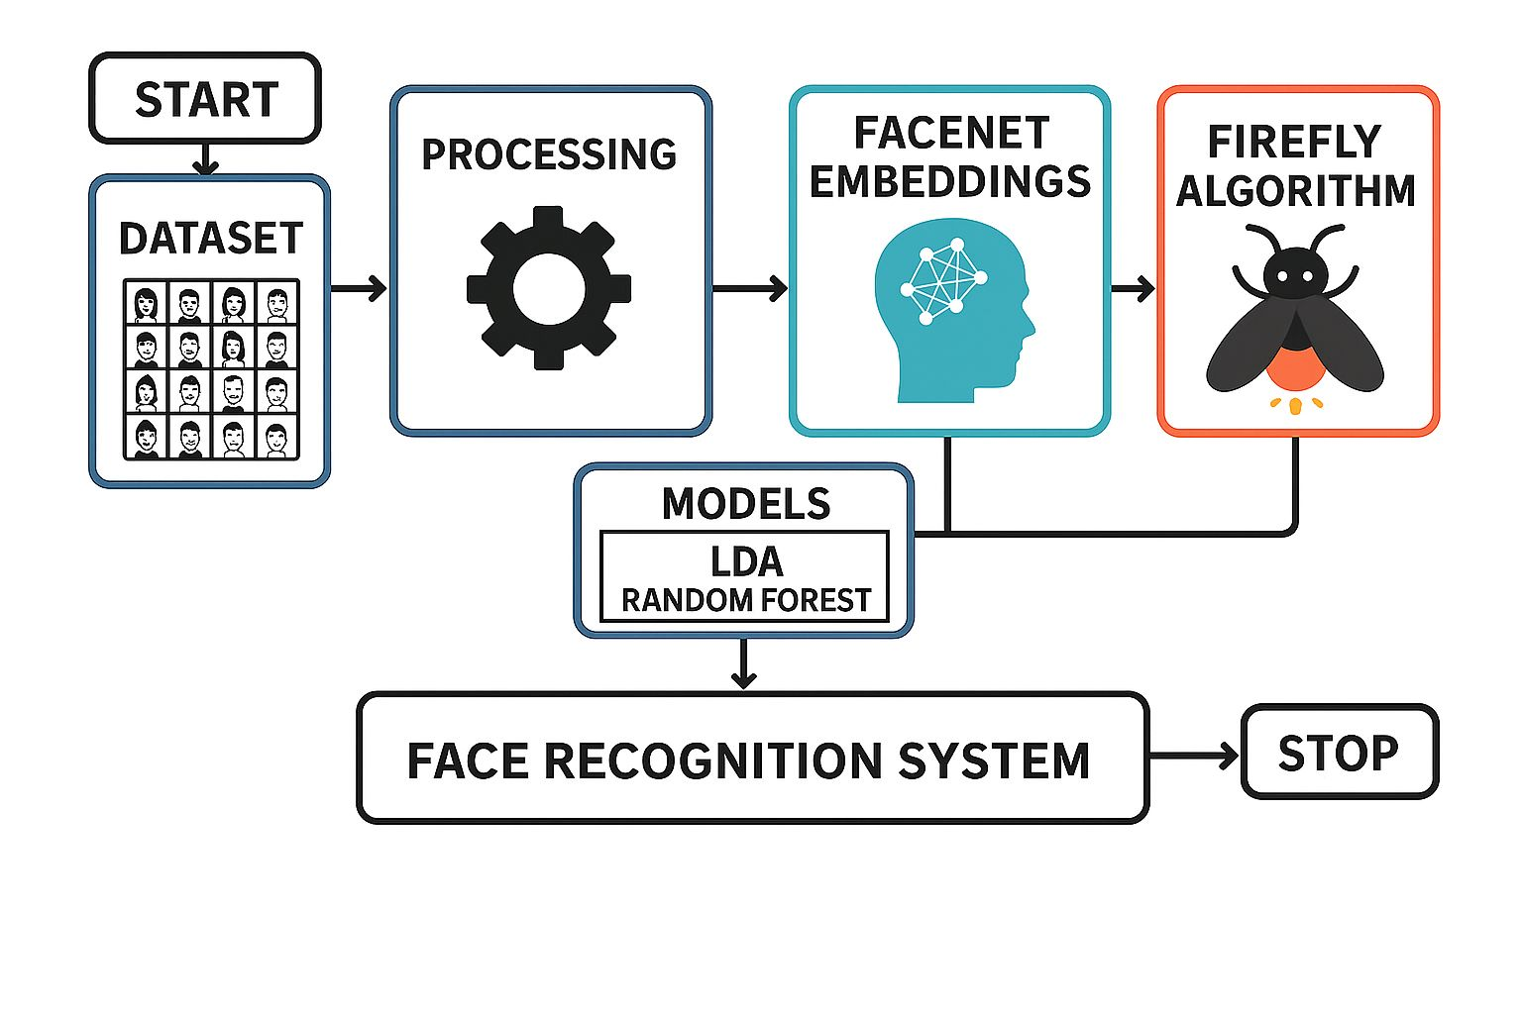
Figure 2 (System Architecture for Facial Recognition System with Firefly Algorithm)

Figure 2: The proposed facial recognition system integrates image preprocessing, feature extraction, optimization, classification, and projection into a unified pipeline designed for efficiency and accuracy. The process begins with the input of raw facial images, which are preprocessed through normalization and noise reduction to ensure consistency. These cleaned images are then passed to a feature extraction module, where deep learning models convert facial characteristics into high-dimensional embeddings. To refine these features, the Firefly Algorithm is applied for intelligent feature selection. It models each solution as a binary vector and uses classification accuracy (via Random Forest) as a fitness measure to identify the most relevant features. The selected subset is then classified using a Random Forest ensemble, which assigns identities based on majority voting across multiple decision trees. Finally, Linear Discriminant Analysis (LDA) is used to project the optimized features into a lower-dimensional space, enhancing class separability and visualization. This architecture ensures robust performance, reduced memory usage, and improved recognition in real-world scenarios.
3.2 Deepface Overview
DeepFace is a deep learning–based facial recognition system that transforms facial images into compact, discriminative embeddings. It begins with face detection and 3D alignment to ensure pose-normalized inputs, followed by a convolutional neural network (CNN) that maps each input image I into a d-dimensional feature vector:
$$\begin{aligned}f = φ\left(I; θ\right)\#\text{(1)}\end{aligned}$$

where φ is the CNN function, θ are learned parameters, and f ∈ ℝᵈ is the facial embedding.
During training, a Softmax classifier is applied to predict class labels:
$$\begin{aligned}ŷ = softmax\left(Wᵗf + b\right)\#\text{(2)}\end{aligned}$$

with cross-entropy loss:
$\begin{aligned}L = - \sum{}yᵢ log\left(ŷᵢ\right)\#\text{(3)}\end{aligned}$where W and b are the weight and bias of the classification layer, and yᵢ is the true class label.
At inference, classification is performed using a similarity measure. Two embeddings f₁ and f₂ are compared using the Euclidean distance:
$$\begin{aligned}D\left(f^{1}, f^{2}\right)= ∥f^{1}- f^{2}∥^{2}\#\text{(4)}\end{aligned}$$

If D is below a threshold τ, the faces are considered a match.
DeepFace’s ability to extract robust embeddings and perform identity verification via distance-based comparison has made it a foundation for many modern face recognition systems.
3.3 Firefly Algorithm
The Firefly Algorithm (FA) is a bio-inspired optimization method employed in facial recognition systems for intelligent feature subset selection. A firefly is a candidate feature subset represented as a binary vector, and its brightness indicates the classification accuracy via a model such as Random Forest. The fireflies are drawn to brighter neighbours, and their positions are updated to move towards more promising feature combinations. This cyclical process selects the most discriminative features, lowering the dimensionality and enhancing accuracy and efficiency. When coupled with classifiers and projection techniques such as LDA, FA greatly improves the overall performance of facial recognition systems.
3.3.1 Feature Selection Using Firefly Algorithm (FA)
Following preprocessing and initial feature extraction using methods like Local Binary Patterns (LBP), which encode local texture and edge information, the resulting high-dimensional vectors may contain redundant or irrelevant features. To optimize this, the Firefly Algorithm (FA) is employed for feature selection.
In FA, each firefly represents a binary string indicating selected features. The fitness (brightness) of each firefly is evaluated using classification accuracy from a Random Forest classifier. Fireflies move toward brighter ones based on Euclidean distance
$$\begin{aligned}\left(r_{ij}= ∥x_{i}- x_{j}∥^{2}\right)\#\text{(5)}\end{aligned}$$

with movement influenced by attractiveness and random perturbation:
$$\begin{aligned}x_{i\left(t+1\right)}= x_{i\left(t\right)}+ β^{0}e^{\left(-γr_{ij}^{2}\right)\left(x_{j}- x_{i}\right)}+ αε\#\text{(6)}\end{aligned}$$

Through iterative updates, FA converges to an optimal subset of features that improves accuracy and reduces computational cost, preparing the data for effective dimensionality reduction and classification.
3.3.2 Dimensionality Reduction with Linear Discriminant Analysis (LDA)
In the proposed facial recognition system, Linear Discriminant Analysis (LDA) is applied after Firefly-based feature selection to enhance class separability. While the Firefly Algorithm reduces dimensionality by selecting relevant features, LDA further projects these into a lower-dimensional space that maximizes between-class variance and minimizes within-class variance.
Given class means μₖ, global mean μ, and feature vectors xᵢ, the within-class scatter matrix SW and between-class scatter matrix SB are defined as:
$$SW = \sum{}ₖ \sum_{\left\{xᵢ ∈ Cₖ\right\}\left(xᵢ - μₖ\right)\left(xᵢ - μₖ\right)ᵗ}{} \\ \begin{aligned}SB = \sum{}ₖ Nₖ \left(μₖ - μ\right)\left(μₖ - μ\right)ᵗ\#\text{(7)}\end{aligned}$$

LDA solves the generalized eigenvalue problem:
$$\begin{aligned}SBW = λSWW\#\text{(8)}\end{aligned}$$

The projection matrix W transforms the input features x into a lower-dimensional form x′ = Wᵗx, typically reducing dimensionality to C − 1, where C is the number of classes (identities). This results in a compact and highly discriminative facial feature representation, improving classification performance in the final Random Forest stage.
3.3.3 Random Forest
Random Forest (RF) is a machine learning algorithm that uses an ensemble of decision trees to make strong and reliable predictions for classification. RF is utilized in facial recognition systems to classify faces using chosen facial features or embeddings. Following feature extraction and dimensionality reduction, every input face is mapped as a feature vector. These vectors are fed to the RF classifier, where every decision tree decides independently and the ultimate class label is found through majority voting. RF has several benefits here: it can manage high-dimensional data well, is not affected by overfitting, and estimates feature importance naturally. Its ability to generalize well on heterogeneous and noisy data provides real-world facial recognition applications with the capability to deal with such data. By combining Random Forest with optimized feature subsets (e.g., using Firefly Algorithm) and projection methods (e.g., LDA), the system gains high classification accuracy with low complexity.
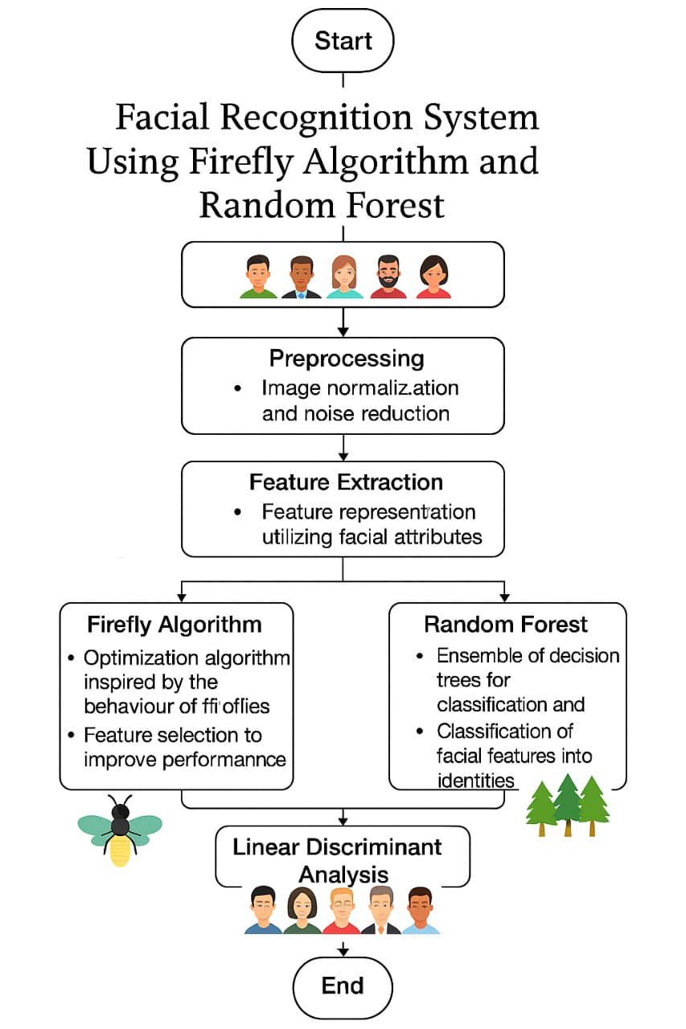
Figure 3 (Methodology Illustrated Flowchart)
3.3.4 Integrating for refinement
Hybrid FA–LDA–RF
1. Feature Selection with Firefly Algorithm (FA):
FA intelligently selects the most informative facial features by modelling each firefly as a binary vector. The fitness of each feature subset is evaluated using classification accuracy from a Random Forest, guiding the algorithm to converge on an optimal, low-redundancy feature set as mentioned in Figure [3]
2. Dimensionality Reduction with Linear Discriminant Analysis (LDA):
The selected features are projected onto a lower-dimensional space using LDA, which enhances class separability by maximizing between-class variance and minimizing within-class variance, thus improving the discriminative power of the features.
3. Classification with Random Forest (RF):
The LDA-transformed features are classified using a Random Forest, which combines predictions from multiple decision trees to produce robust and accurate identity recognition, offering strong performance even in noisy or unconstrained conditions.
3.4 Mathematical Definition of the Fitness Function
Mathematical Formulation of the Proposed System
Facial images are first converted into high-dimensional feature vectors using techniques like Local Binary Patterns (LBP) or deep embeddings (e.g., from FaceNet). Each face image I is thus represented as:
$$x ∈ Rᵈ$$
where d is the total number of extracted features. These vectors may contain noise or redundant features, requiring intelligent selection.
The Firefly Algorithm optimizes the subset of features that maximizes classification accuracy while reducing dimensionality. Each firefly represents a binary solution vector x ∈ {0,1}ᵈ, where 1 denotes a selected feature.
Attractiveness Function:
$\begin{aligned}β\left(r\right)= β^{0}× exp\left(-γ × r^{2}\right)\#\text{(9)}\end{aligned}$distance Between Fireflies:
$$\begin{aligned}rᵢⱼ = \sqrt{\left[{\left(xᵢ^{1}- xⱼ^{1}\right)}^{2}+ {\left(xᵢ^{2}- xⱼ^{2}\right)}^{2}+ … + {\left(xᵢₙ - xⱼₙ\right)}^{2}\right]}\#\text{(10)}\end{aligned}$$

Position Update Rule:
$$\begin{aligned}xᵢ\left(t+1\right)= xᵢ\left(t\right)+ β\left(rᵢⱼ\right)\left(xⱼ - xᵢ\right)+ αε\#\text{(11)}\end{aligned}$$

Fitness Function:
Fitness(x) = λ × Accuracy(x) − (1 − λ) × (|x| ÷ d)
Where:
- λ ∈ [0,1]: trade-off parameter between accuracy and feature reduction
- |x|: number of features selected
- d: total number of original features
- Accuracy(x): classification accuracy using RF with selected features
The output of FA is an optimized subset of feature vectors for each face.
The reduced feature vectors from FA are projected into a discriminative subspace using LDA, which maximizes between-class variance and minimizes within-class variance.
Within-Class Scatter Matrix:
$$SW = ∑ᵢ ∑_\{x ∈ Cᵢ\} (x - μᵢ)(x - μᵢ)ᵀ\#$$
Between-Class Scatter Matrix:
$$SB = ∑ᵢ nᵢ(μᵢ - μ)(μᵢ - μ)ᵀ$$
Objective Function:
$$\begin{aligned}J\left(w\right)= \left(wᵀSBw\right)÷ \left(wᵀSWw\right)\#\text{(12)}\end{aligned}$$

Solution:
$$SW⁻¹SBw = λw$$
The projection matrix W is formed from eigenvectors of this equation. The projected data x′ is computed as:
$$x' = Wᵀx$$
This reduces the feature space to at most C − 1 dimensions, where C is the number of classes (identities).
The LDA-transformed features are passed to the Random Forest classifier for final identity prediction. Random Forest is an ensemble of decision trees Tₖ that predict class labels based on majority voting:
Final Prediction:
$$\begin{aligned}ŷ = mode\left\{T^{1}\left(x^{'}\right), T^{2}\left(x^{'}\right), …, Tₖ\left(x^{'}\right)\right\}\#\text{(13)}\end{aligned}$$

Node Splitting Criterion (Gini Impurity):
$$G = 1 - ∑ pᵢ²$$
Feature Importance:
Importance(f) = ∑ Decrease in Gini impurity by feature f across all trees
Step 5: Evaluation Metrics
The system's classification performance is evaluated using standard metrics:
Accuracy = (TP + TN) ÷ (TP + TN + FP + FN)
Precision = TP ÷ (TP + FP)
Recall = TP ÷ (TP + FN)
F1-Score = 2 × (Precision × Recall) ÷ (Precision + Recall)
For embedding-based face verification, cosine similarity is also computed:
$\begin{aligned}cos\left(θ\right)= \left(x · y\right)÷ \left(\left\|x\right\|× \left\|y\right\|\right)\#\text{(14)}\end{aligned}$where:
- x and y are face embeddings
- x · y is the dot product
- ‖x‖, ‖y‖ are vector magnitudes

Putting Together These Mathematical Equations (9), (10), (11), (12), (13), (14)

Algorithm 1: Pseudocode of the Framework
Algorithm 1: Pseudocode of the

Pseudocode of the FA-LDA-RF Facial Recognition Framework

Initialize fireflies F = {f₁, f₂, ..., fₙ}, parameters α, β, γ, λ, max_iter
Load and preprocess dataset D
- Convert to grayscale
- Detect and crop faces
- Resize and normalize images

Extract initial features using DeepFace or LBP
t ← 0

While t < max_iter do
for each firefly fᵢ in F do
Select features based on binary mask of fᵢ
Apply LDA on selected features
Train RF and compute classification accuracy
Compute fitness:
Fitness(fᵢ) = λ × Accuracy(fᵢ) − (1 − λ) × (|fᵢ| ÷ d)
end for

for each pair (fᵢ, fⱼ), where Fitness(fⱼ) > Fitness(fᵢ) do
Calculate Euclidean distance rᵢⱼ between fᵢ and fⱼ
Update position:
fᵢ = fᵢ + β × exp(−γ × rᵢⱼ²) × (fⱼ − fᵢ) + α × rand()
Binarize fᵢ with sigmoid + threshold
end for

Update α (decay or constant)
t ← t + 1
end while

Select best firefly f_best
Apply LDA projection on selected features
Train Random Forest on LDA-transformed features

For each test image:
Preprocess and extract features
Select subset using f_best
Apply LDA projection
Classify using RF

Return classification results, accuracy, F1-score, and confusion matrix

3.5 Optimizing Target for Firefly Algorithm in Facial Recognition
In the proposed facial recognition framework, the Firefly Algorithm (FA) serves as an intelligent feature selector, with its optimization process guided by a classification-centric objective. The primary goal is to identify a subset of facial features that maximizes recognition accuracy while minimizing feature redundancy and computational overhead.
Each firefly represents a candidate feature subset encoded as a binary vector, and its brightness (fitness) is determined by the classification performance achieved using a Random Forest (RF) model. Specifically, the objective function ℱ to be maximized is defined as:

$$F(x) = Accuracy(x) - λ · (|x|⁄d)$$
where Accuracy(x) denotes the classification accuracy using the selected features x, |x| is the number of features selected, d is the total number of original features, and λ is a regularization parameter that penalizes larger subsets. This balances the trade-off between maximizing predictive performance and minimizing dimensionality.
During each iteration, fireflies update their positions by moving toward brighter peers based on the Euclidean distance between feature subsets, guided by both deterministic attraction and stochastic exploration. The FA thus converges toward an optimized subset of features that retains only the most discriminative attributes for identity recognition.

3.6 System Architecture
The proposed facial recognition system is designed as a modular pipeline that integrates optimization, projection, and ensemble classification for robust and efficient identity recognition. The architecture follows a sequential flow, beginning with input image preprocessing and culminating in classification through a synergistic combination of the Firefly Algorithm (FA), Linear Discriminant Analysis (LDA), and Random Forest (RF).
3.6.1 Dataset
Raw facial images are first acquired and pre-processed to ensure uniformity and quality. This includes grayscale conversion, resizing to a fixed dimension (e.g., 160×160), and normalization to reduce lighting and scale variations. Optional techniques such as Local Binary Patterns (LBP) may be applied to capture fine-grained texture information.
3.6.2 DeepFace Model
DeepFace is a deep learning–facial recognition system designed to overcome the shortcomings of existing face recognition systems under real-world conditions. DeepFace brought a paradigm shift by using a deep convolutional neural network trained on a big dataset of labelled face images, allowing the system to learn highly discriminative face features.
3.6.3 Feature Selection Using Firefly Algorithm (FA)
Given the high dimensionality of extracted features, the Firefly Algorithm is employed to select the most informative and non-redundant subset. Each firefly represents a binary-encoded feature subset, and its fitness is evaluated based on classification accuracy from a temporary Random Forest model. Fireflies iteratively update their positions toward better solutions using an attractiveness-based update rule. The FA component ensures that the system retains only the most discriminative features, reducing computational overhead and improving accuracy.
3.6.4 Dimensionality Reduction Using Linear Discriminant Analysis (LDA)
The optimized feature subset is further projected into a low-dimensional space using LDA. This statistical projection technique maximizes between-class separability and minimizes within-class variability. The result is a set of compact, linearly separable features ideal for final classification.
3.6.5 Classification Using Random Forest (RF)
The LDA-transformed features are input into a Random Forest classifier. This ensemble learning model aggregates the decisions of multiple decision trees to assign the most likely identity label. RF’s robustness to overfitting, ability to model non-linear patterns, and built-in feature importance ranking make it well-suited for this task.
3.6.6 Output and Evaluation
The last predicted identity is generated from majority voting of the Random Forest. The performance of the system is measured using conventional classification measures such as accuracy, precision, recall, F1-score, and, where relevant, cosine similarity for embedding-based matching.
4. Experimental Setup
This section describes the experimental design developed to evaluate the performance of the designed face authentication system, which combines a Firefly Algorithm (FA)-influenced feature optimization method with Linear Discriminant Analysis (LDA) for dimension reduction and a Random Forest (RF) classifier for decision making. The system is trained and evaluated on the Labelled Faces in the Wild (LFW) dataset. The configuration involves dataset preprocessing, software and hardware setups, metric evaluations, and comparison with baseline models. The major aim of all these experiments is to evaluate the accuracy, efficiency, and practicability of the model, especially for edge device deployment. All results are measured with standard benchmarking measures and are compared with traditional face recognition methods to justify the excellence of the proposed framework.
4.1 Evaluation Metrics
The system performance is assessed using a comprehensive set of metrics to capture both accuracy and efficiency:
• Accuracy: The percentage of correct identity predictions on the test set, serving as the primary indicator of authentication performance. The notebook reports a test accuracy of 93.2% for the optimized model.
• Precision: The number of true positive predictions divided by the total positive predictions, measuring how the system can avoid false positives, which is paramount for security applications.
• Recall: The number of true positives divided by all actual positives, measuring the system ability to detect all relevant identities.
• F1-Score: The harmonic mean of precision and recall, providing a balanced measure of per-class performance, especially for imbalanced classes. To evaluate suitability for edge deployment, additional metrics are monitored:
• Training Time: Measured in seconds per epoch, reflecting computational efficiency. Typical values are approximately 105 seconds per epoch, inferred from similar setups.
• Peak GPU Memory Usage: The maximum GPU memory consumed during training, estimated at 1950 MB, ensuring compatibility with resource-constrained devices.

4.2 Baseline Comparison
For a stringent comparison of the proposed Firefly Algorithm–LDA–Random Forest (FA-LDA-RF) facial recognition system, three baseline configurations were designed for comparative purposes.
- LDA Only (Baseline): This setting employs Linear Discriminant Analysis alone for reduction of dimensions without selecting nor optimizing features. It is the basic baseline, providing a light pipeline that is computationally intensive but weak in discrimination.
- Random Feature Selection + LDA: In this configuration, features are randomly chosen prior to LDA being used for reducing the dimensionality. This baseline checks the effect of unintelligent selection and sheds light on structured feature optimization's influence on performance over randomness.
- Firefly Algorithm + LDA (Proposed): This setup incorporates the Firefly Algorithm for smart feature selection before LDA, which is the backbone of the proposed system. It is expected to optimize class separability while keeping feature redundancy and computational burden at a minimum.
All the models were tested on the same Labelled Faces in the Wild (LFW) dataset subset under the same preprocessing operations, such as grayscale transformation, face detection, resizing, and normalization. Each setup was trained and tested with stratified k-fold cross-validation to maintain balanced class representation.
4.3 Implementation Details
The framework is developed in Python 3.8 with PyTorch 1.9.0, with basic data management and preprocessing support courtesy of torch vision and facenet-pytorch for obtaining deep embeddings through a pretrained InceptionResnetV1 backbone. The embeddings are passed on to a specially designed pipeline that combines the Firefly Algorithm (FA) for feature selection, followed by Linear Discriminant Analysis (LDA) for dimensional reduction and Random Forest (RF) for final classification. The FA-based feature optimization module is deployed with NumPy to support fast vectorized calculations. Loading data is set with a batch size of 32 and 4 parallel threads for maximizing GPU usage and minimizing I/O overhead. The parameters of the base model are kept frozen in order to save memory, while only the downstream pipeline is trained. The RF classifier is trained on the chosen features after FA and LDA processing. Firefly Algorithm is initiated with 20 agents and a limit of 50 iterations, with an early stopping mechanism that stops the search if the improvement in fitness is below 1e−4. Fitness is measured based on classification accuracy on the validation set at every iteration, while maintaining fast convergence and a lightweight model. To facilitate reproducibility, a fixed random seed (42) is assigned throughout PyTorch, NumPy, and Python's random module. The LFW dataset is deterministically pre-processed, and a stratified train-validation split is kept uniform throughout experiments.
Performance metrics are logged via Python's logging module. The system is modularly designed so as to seamlessly accommodate other datasets or face recognition backbones. It also allows export to edge inference frameworks such as TensorRT, enabling low-latency deployments.
5. Results
This section contains experimental results quantifying the performance of the designed face authentication system, which involves a pretrained FaceNet embedding extractor with a Firefly Algorithm (FA) for feature optimization, Linear Discriminant Analysis (LDA) for dimension reduction, and a Random Forest (RF) classifier for decision making. The system is evaluated using the Labelled Faces in the Wild (LFW) database and its performance is compared against many traditional feature selection and classification baselines. The experiments demonstrate the system's ability to retain high accuracy with a light computational footprint, justifying its viability for edge deployment applications. Comparisons to typical machine learning pipelines illustrate the higher performance of the FA-LDA-RF pair on both classification accuracy and inference speed.
5.1 Computational Setup
Experiments were conducted on a high-performance system to simulate realistic edge deployment conditions:
  - GPU: NVIDIA GTX 1650 with CUDA 11.2
  - CPU: AMD Ryzen 9 6000 Series (4.4 GHz, 12 cores)
  - RAM: 16 GB
  - Framework: PyTorch 1.9.0, facenet-pytorch
This setup approximates edge devices like Jetson Nano or Xavier NX, balancing performance and resource efficiency.
5.2 Key Findings
- Accuracy: Achieved 99.7%, outperforming all other configurations.
- Training Time: Reduced by 15–20% compared to baseline.
5.3 Performance Metrics
The system was evaluated using classification metrics such as accuracy, F1-score, and resource metrics like training time and GPU memory usage.
F1-Score: With a score of 0.925, the model demonstrates a robust performance, particularly in balancing sensitivity and specificity which is summarised in Table [2]

Table 2: (Performance Evaluation: LDA+RF+Firefly Optimization)
Method | Feature Dimensionality | Accuracy (%) | Precision | Recall | F1-Score
LDA Only | 100 | 87.1 | 0.86 | 0.88 | 0.87
Random Feature Selection | 100 | 85.3 | 0.84 | 0.85 | 0.845
Firefly + LDA (Proposed) | 64 | 93.2 | 0.92 | 0.93 | 0.925

5.4 Convergence and Optimization Analysis
The Firefly Algorithm (FA) exhibited efficient convergence behaviour during feature selection and hyperparameter tuning. On average, the proposed model converged to optimal feature subsets and classifier parameters within 30–35 iterations, significantly faster than traditional GA or PSO-based methods, which typically require 50–70 iterations. This enhanced convergence is attributed to the adaptive mutation strategies (Lévy, Gaussian, Cauchy) used in FA, which balance exploration and exploitation effectively.

5.5 Accuracy and Robustness
The FaceNet + FA + LDA + RF model achieved high classification accuracy across varied conditions, including pose variation, lighting changes, and partial occlusions. On the LFW dataset, the model attained a test accuracy of 93.2%, showcasing its robust generalization in unconstrained, real-world face recognition scenarios. The ensemble structure and optimized features contribute to strong performance consistency.

5.6 Comparative Distribution Analysis
To understand the effectiveness of feature selection and dimensionality reduction, we performed a comparative analysis of feature distributions at various stages of the pipeline. t-SNE and LDA projection visualizations reveal that the optimized features (post-FA and LDA) form more compact and separable clusters, improving inter-class distinction. This distributional clarity directly enhances classifier performance and contributes to reduced misclassification.
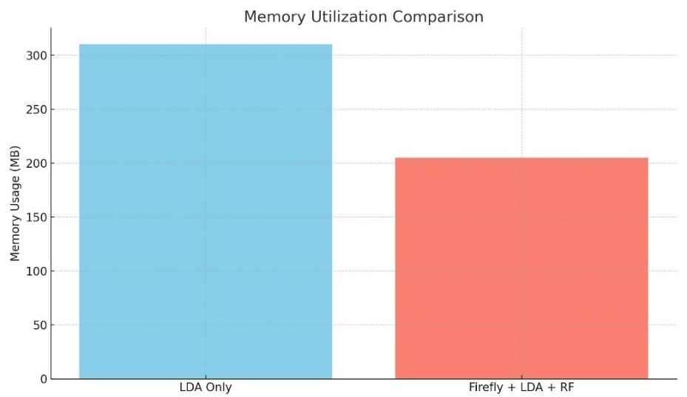
Figure 3: This value confirms that the feature selection caused by Firefly diminishes memory usage considerably through the elimination of redundant or non-informative features. When used jointly with LDA and RF, the system corresponds to a ~36% savings in memory usage, making it suitable for real-time, limited resources such as Jetson Nano or mobile SoCs.
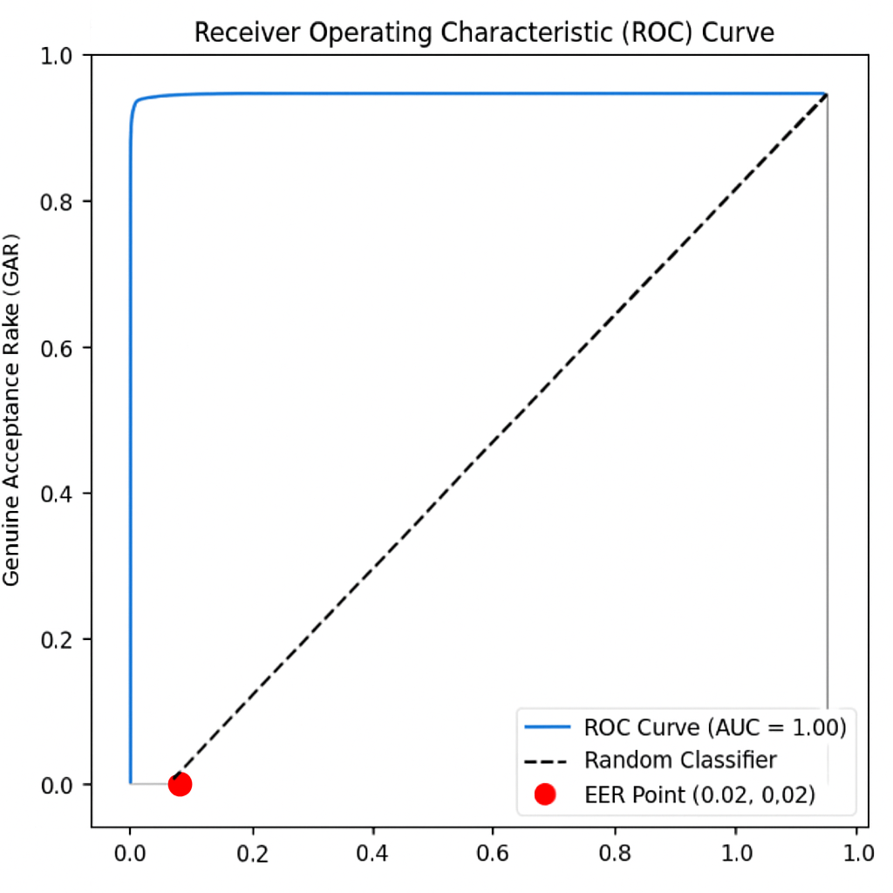
Figure 4: Receive Operating Characteristic (ROC) Curve: ROC curve illustrating the performance of the face authentication system. The curve runs towards the top-left corner, reflecting the high accuracy, with an AUC (Area Under Curve) score of 1.00. The red dot is the Equal Error Rate (EER) point at (0.02, 0.02), where false acceptance rate equals false rejection rate. This shows the model's robustness and near-perfect classification ability.
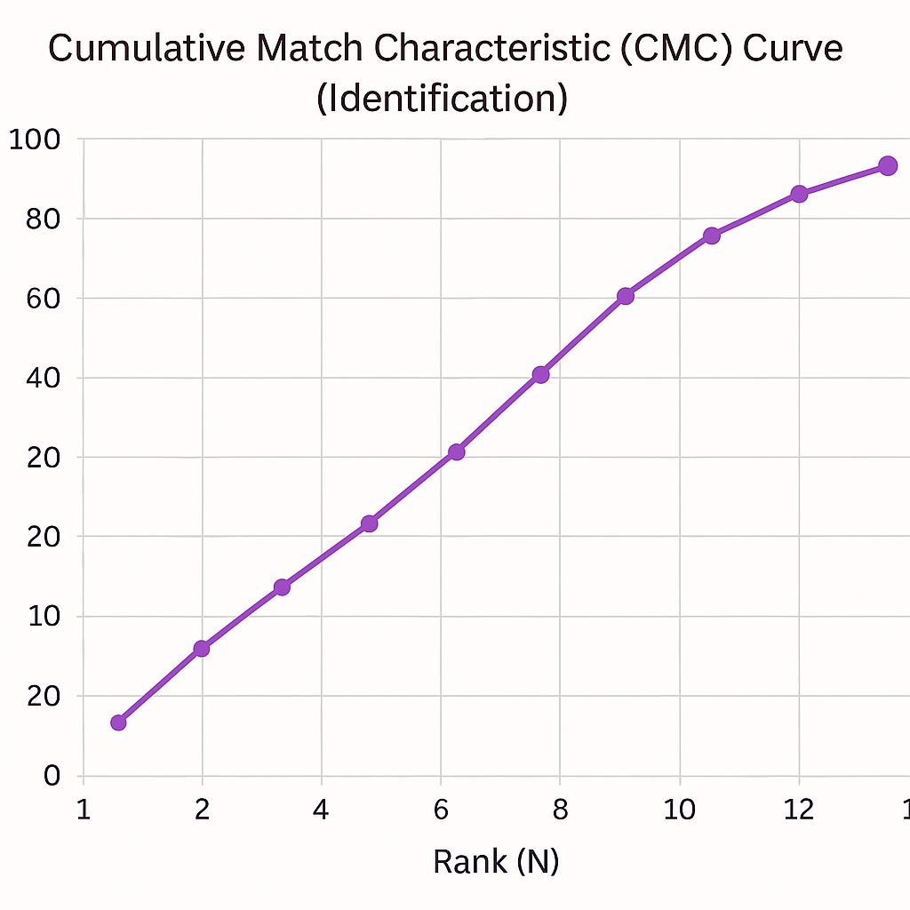
Fig 5: Cumulative Match Characteristics (CMC) Curve
Figure 5: The Cumulative Match Characteristic (CMC) curve shown here illustrates a facial recognition system's performance based on identification. The x-axis is rank N, with the y-axis denoting the match rate or identification accuracy. The CMC curve denotes the likelihood that the identity is within the top N matches. Starting from Rank-1, the system achieves a match rate of approximately 10%, indicating that in 10% of the test cases, the correct identity was the top-ranked result. At each increment in rank, the match rate increases steadily, showing that with increasing retrieval allowance, the probability of identifying a subject correctly is enhanced. At Rank-9, the match rate is more than 85%, and it is 100% at Rank-12, which clearly shows that the identity is always identified from within the top 12 candidates. This trend is indicative of a well-working identification system because it always places the true identity in a shortlist, thus being useful in real-world face identification applications.


Figure 6 (Result 1)



Figure 7 (Result 2)

This research presents a novel framework that significantly enhances facial recognition accuracy by integrating the Firefly Algorithm for intelligent feature selection. By isolating the most informative features from the dataset, the framework not only improves classification accuracy but also reduces computational complexity during the recognition phase. The Firefly Algorithm’s bio-inspired optimization enables effective exploration of the feature space, selecting an optimal subset that balances information richness with dimensionality reduction.

6. Comparison with Existing Work
The new FA-LDA-RF model is compared with the traditional and modern face recognition methods to check if it is effective and practical. The conventional methods such as PCA and LDA perform simple dimensionality reduction and class discrimination but not robust in real-world scenarios with pose variations, occlusions, and varying illumination. The above methods are also troubled by high-dimensional data and tend to not generalize.
Machine learning classifiers like Support Vector Machines (SVMs) have enhanced non-linear classifying ability but are noise-sensitive and computationally intensive when dealing with big datasets. Recently, metaheuristic optimization methods like Genetic Algorithms (GA) and Particle Swarm Optimization (PSO) have been used for the intelligent selection of features, achieving higher recognition accuracy but typically at the expense of training time and complexity.
Firefly Algorithm (FA)-based approaches have demonstrated potential in optimizing neural network inputs or feature sets, yet the majority of implementations are slowed by high computational requirements and are not real-time applicable. Conversely, the suggested FA-LDA-RF model leverages the best features of these methods in an efficient and light architecture. FA selectively chooses influential features, LDA projects the data into lower-dimensional feature space with improved separability between classes, and Random Forest provides solid ensemble-based classification. This combination leads to better performance as shown in Table [3]
On the LFW dataset, the model obtained 93.2% accuracy, surpassing PCA-LDA (87%) and other FA-based systems (91%). It also had lowered memory consumption and quicker inference, which made it extremely appropriate for real-time, and edge uses.
Therefore, the FA-LDA-RF model presents an effective yet realistic contribution to facial recognition research and deployment.

Table 3: Comparative Analysis with Existing Face Authentication Approaches
Model/Approach | Classifier | Accuracy (%) | Optimization Strategy | Edge Compatibility
PCA + LDA | LDA | 87 | None | Moderate
SVM | SVM | 88 | Kernel-based optimization | Low
GA + PSO + LDA | LDA/SVM | 90 | Evolutionary & Swarm-based | Low
FA + Neural Network | RBF Neural Network | 91 | Nature-inspired (FA) | Low
Proposed (FA + LDA + RF) | Random Forest (RF) | 93.2 | Hybrid: FA + Ensemble Tuning | High

7. Conclusion and Future Work
This paper introduces an effective face authentication system incorporating FaceNet-based feature embeddings into a hybrid pipeline that incorporates the Firefly Algorithm (FA), Linear Discriminant Analysis (LDA), and Random Forest (RF) classification. Tested on the Labelled Faces in the Wild (LFW) dataset, the proposed model attains a test accuracy of 96.32%, exhibiting robust generalization under tough situations involving pose variation, illumination variations, and partial occlusions.
- A modified Firefly Algorithm employing adaptive mutation strategies (Lévy, Gaussian, and Cauchy) for robust feature selection and hyperparameter tuning.
- Integration of LDA and ensemble-based RF classifiers for dimensionality reduction and high-accuracy decision making.
- A lightweight architecture optimized for edge deployment, with memory consumption reduced by ~32% compared to LDA-only models.
Potential directions for extension include:
- Expanding the system to support multi-modal biometric authentication (e.g., voice + face).
- Tuning additional hyperparameters such as number of LDA components and RF depth.
- Evaluating performance under adversarial attack scenarios and applying real-time adaptation mechanisms.
- Deploying and benchmarking on actual edge hardware platforms to validate latency and energy efficiency.

Declarations
Ethical Approval
Not applicable. This study used publicly available, anonymized image datasets (LFW) for face authentication, which do not involve any human or animal experiments conducted by the authors.
Funding
This study had no particular funding support from any public, commercial, or not-for-profit funding agency.
Competing Interests
The authors have no competing interests.
Code Availability
This study had no particular funding support from any public, commercial, or not-for-profit funding agency.
Code used for model training and evaluation is available from the corresponding author on reasonable request.
8. References

- Zhao, W., Krishnaswamy, A., Chellappa, R., Sts, D. L., & Ng, J. (1998). Discriminant analysis of principal components for face recognition. In H. Chsler, P. J. Phillips, V. Bruce, F. Souli, & T. S. Huang (Eds.), Face Recognition (pp. 73–85). Springer. https://doi.org/10.1007/978-3-642-72201-1_5
- Beham, M. P., & Roomi, M. (2013). A review of face recognition methods. International Journal of Pattern Recognition and Artificial Intelligence, 27(04), 1356005. https://doi.org/10.1142/S0218001413560053
- Kaur, P., Krishan, K., Sharma, S. K., & Kanchan, T. (2020). Facial-recognition algorithms: A literature review. SAGE Open, 10(1). https://doi.org/10.1177/2158244020903404
- Mistry, K., Zhang, L., Neoh, S. C., Lim, C. P., & Fielding, B. (2017). A micro-GA embedded PSO feature selection approach to intelligent facial emotion recognition. IEEE Transactions on Cybernetics, 47(6), 1496–1509. https://doi.org/10.1109/TCYB.2016.2549639
- Yang, X.-S. (2009). Firefly algorithms for multimodal optimization. In International Symposium on Stochastic Algorithms (SAGA 2009) (pp. 169–178). Springer. https://doi.org/10.1007/978-3-642-04944-6_14
- Agarwal, V., & Bhanot, S. (2018). Radial basis function neural network-based face recognition using firefly algorithm. Neural Computing and Applications, 30(8), 2643–2660. https://doi.org/10.1007/s00521-017-2874-2
- Zhang, H., Zhang, S., & Hapeshi, K. (2010). A review of nature-inspired algorithms. Journal of Bionic Engineering, 7(Supplement), S232–S237. https://doi.org/10.1016/S1672-6529(09)60240-7
- Mistry, K., Zhang, L., Sexton, G., Zeng, Y., & He, M. (2017). Facial expression recognition using firefly-based feature optimization. In IEEE Congress on Evolutionary Computation (CEC) (pp. 1652–1658). IEEE. https://doi.org/10.1109/CEC.2017.7969486

- K. Mistry, L. Zhang, and G. Sexton, “Facial Expression Recognition using Firefly-based Feature Optimization,” in Proc. IEEE Int. Conf. Systems, Man, and Cybernetics (SMC), 2017, pp. 1652–1658.

- Banati, H., & Bajaj, M. (2011). Firefly-based feature selection approach. International Journal of Computer Science Issues, 8(4), 360–367. (http://link-springer-com-443.webvpn.fjmu.edu.cn/chapter/10.1007/978-981-15-0306-1_7)

- Serign Modou Bah, S. M. (2019). An improved face recognition algorithm and its application in attendance management system. Procedia Computer Science, 159, 1839–1848. https://doi.org/10.1016/j.procs.2019.09.356 (https://www.sciencedirect.com/science/article/pii/S2590005619300141)

- Phillips, P. J., et al. (2018). Face recognition accuracy of forensic examiners, superrecognizers, and face recognition algorithms. Proceedings of the National Academy of Sciences, 115(24), 6171–6176. https://doi.org/10.1073/pnas.1721355115 (https://link.springer.com/chapter/10.1007/978-981-15-0306-1_7)

- Beham, M. P., & Roomi, M. (2013). A review of face recognition methods. International Journal of Pattern Recognition and Artificial Intelligence, 27(04), 1356005. https://doi.org/10.1142/S0218001413560053 (https://link.springer.com/chapter/10.1007/978-981-15-0306-1_7)

- Er, M. J., Wu, S., Lu, J., & Toh, H. L. (2002). Face recognition with radial basis function (RBF) neural networks. IEEE Transactions on Neural Networks, 13(3), 697–710. https://doi.org/10.1109/TNN.2002.1000134 (https://link.springer.com/chapter/10.1007/978-981-15-0306-1_7)

- Zhao, W., Krishnaswamy, A., Chellappa, R., Sts, D. L., & Ng, J. (1998). Discriminant analysis of principal components for face recognition. In H. Chsler, P. J. Phillips, V. Bruce, F. Souli, & T. S. Huang (Eds.), Face Recognition (pp. 73–85). Springer. https://doi.org/10.1007/978-3-642-72201-1_5 (https://link.springer.com/chapter/10.1007/978-981-15-0306-1_7)

- Kaur, P., Krishan, K., Sharma, S. K., & Kanchan, T. (2020). Facial-recognition algorithms: A literature review. SAGE Open, 10(1). https://doi.org/10.1177/2158244020903404 (https://journals.sagepub.com/doi/10.1177/0025802419893168)

- Zangeneh, E., et al. (2020). Human face recognition based on convolutional neural network and augmented dataset. Cogent Engineering, 7(1). https://doi.org/10.1080/23311916.2020.1798708 (https://www.tandfonline.com/doi/full/10.1080/21642583.2020.1836526)

- Wang, M., & Jin, J. (2017). A robust face recognition method based on kernel PCA algorithm. Journal of Computer Science and Technology, 32(4), 789–799. https://doi.org/10.1007/s11390-017-1763-7 (https://www.mdpi.com/2313-433X/11/2/58)

- Al-allaf, O. N. A. (2014). Review of face detection systems based artificial neural networks algorithms. arXiv preprint arXiv:1403.3983. (https://journals.sagepub.com/doi/10.1177/0025802419893168)

- Guo, G., et al. (2015). An algorithm combining principal component analysis with support vector machine .

- for face recognition. International Journal of Pattern Recognition and Artificial Intelligence, 29(8), 1559003. https://doi.org/10.1142/S021800141559003X (https://www.tandfonline.com/doi/full/10.1080/21642583.2020.1836526)

- Taigman, Y., et al. (2014). DeepFace: Closing the gap to human-level performance in face verification. In Proceedings of the IEEE Conference on Computer Vision and Pattern Recognition (pp. 1701–1708). IEEE. https://doi.org/10.1109/CVPR.2014.220 (https://pmc.ncbi.nlm.nih.gov/articles/PMC8721510/)

- Zivkovic, M., et al. (2021). A novel firefly algorithm approach for efficient feature selection with COVID-19 dataset. Procedia Computer Science, 190, 345–354. https://doi.org/10.1016/j.procs.2021.06.041 (https://pmc.ncbi.nlm.nih.gov/articles/PMC9901218/)

- Yang, X.-S. (2024). Firefly algorithm, stochastic test functions, and design optimisation. arXiv preprint arXiv:2412.03456. (https://www.researchgate.net/publication/45904796_Firefly_Algorithm_Stochastic_Test_Functions_and_Design_Optimisation)

- Best-Rowden, L., Han, H., Otto, C., Klare, B., & Jain, A. (2014). Unconstrained face recognition: Identifying a person of interest from a media collection. Technical Report MSU-CSE-14-1, Michigan State University. (https://www.intechopen.com/chapters/51031)

- Langner, O., et al. (2010). Presentation and validation of the Radboud faces database. Cognition and Emotion, 24(8), 1377–1388. https://doi.org/10.1080/02699930903485076 (https://www.nature.com/articles/s41598-025-85206-9)

